**Phase 2: Salesforce Org Setup & Configuration**

**App Name: - “Healthcare Appointment App🧑‍⚕️”**

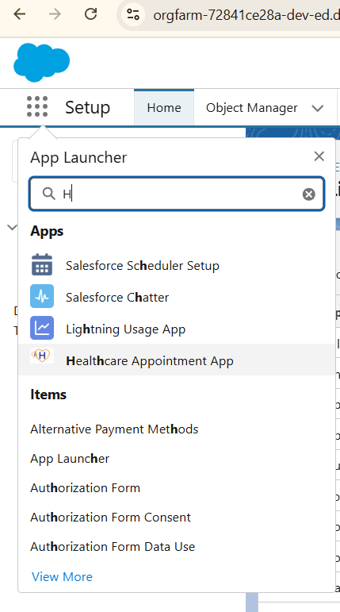

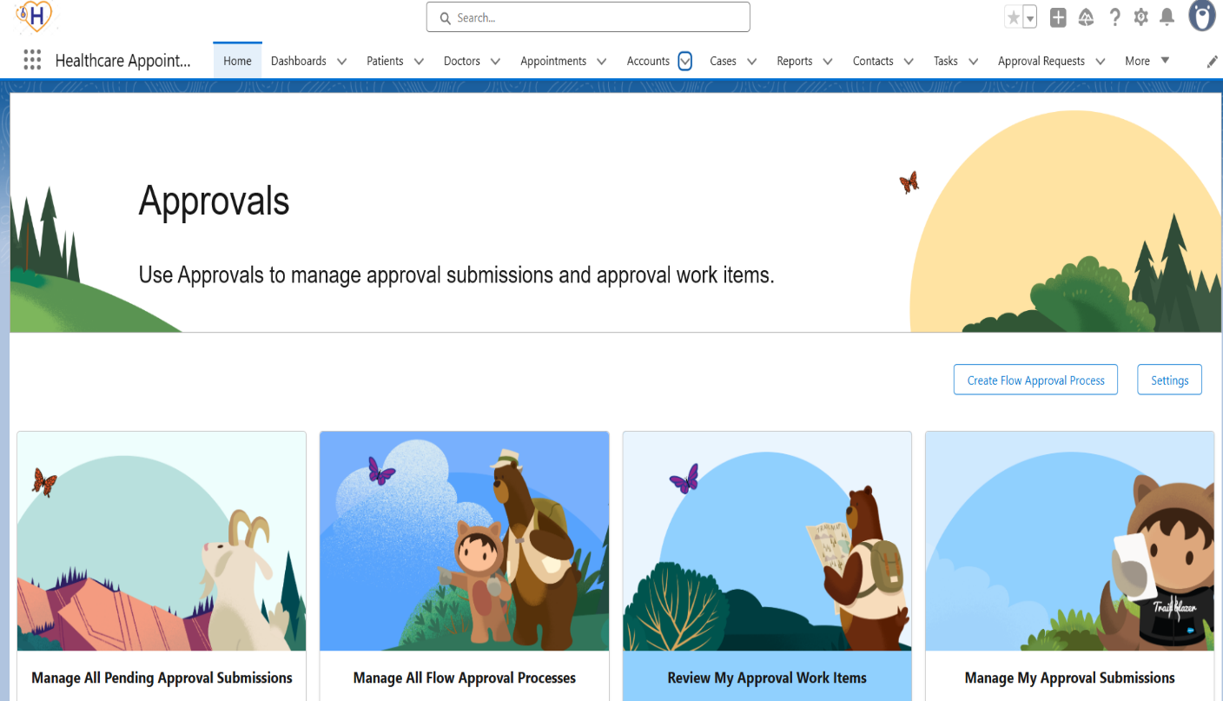

**Custom Objects: -**

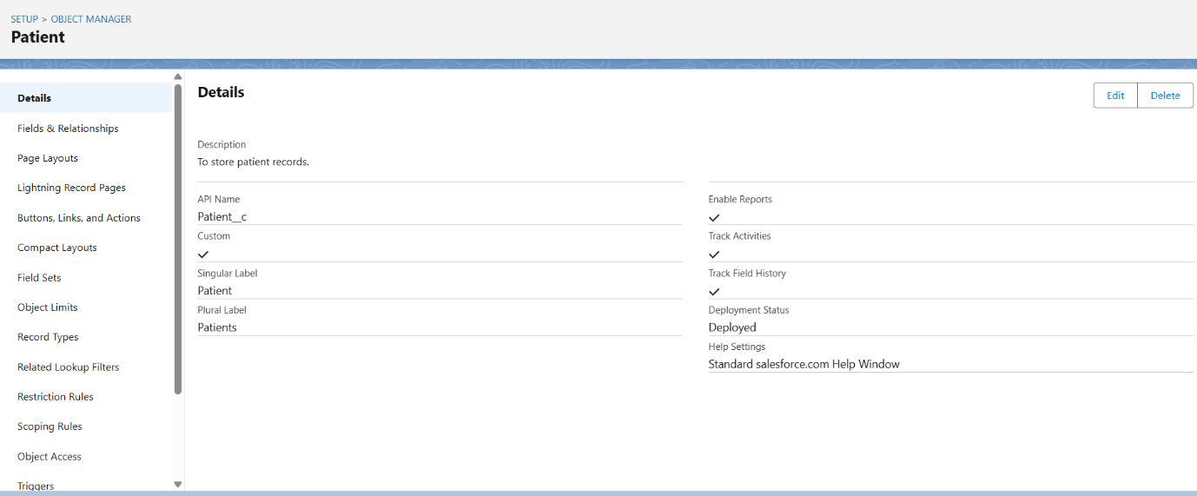

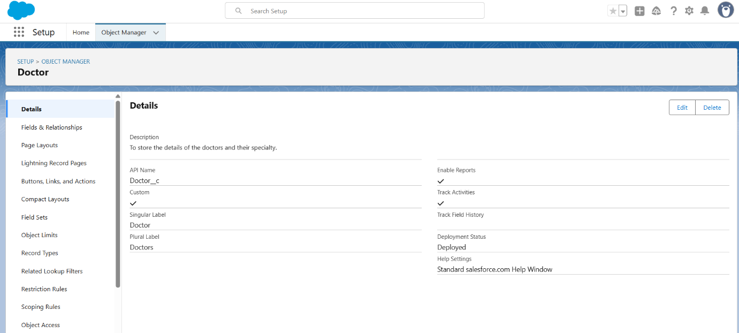

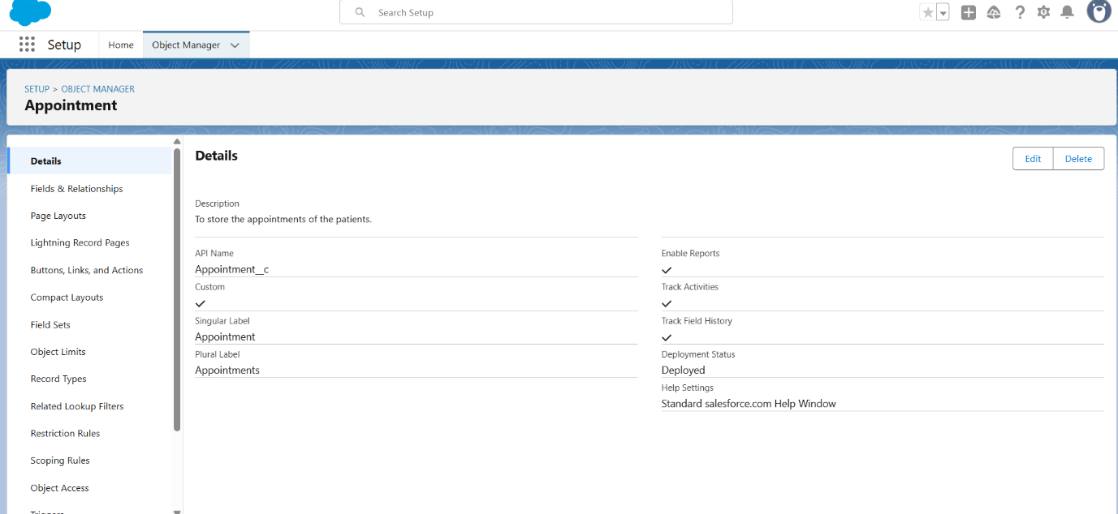

**Fields Added -:**

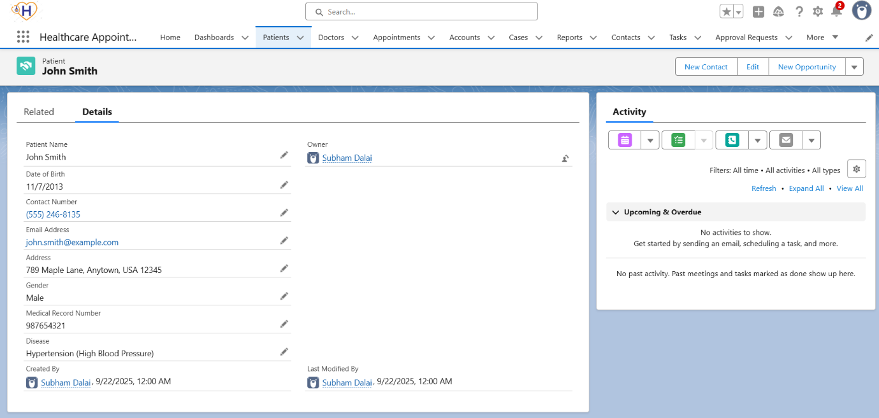

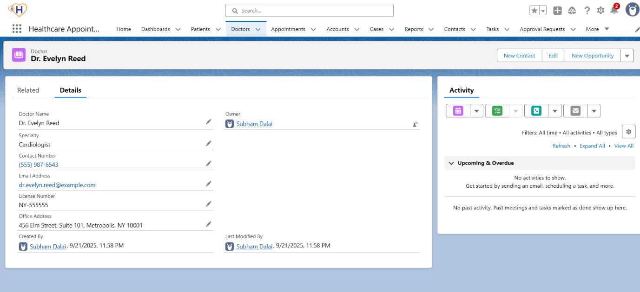

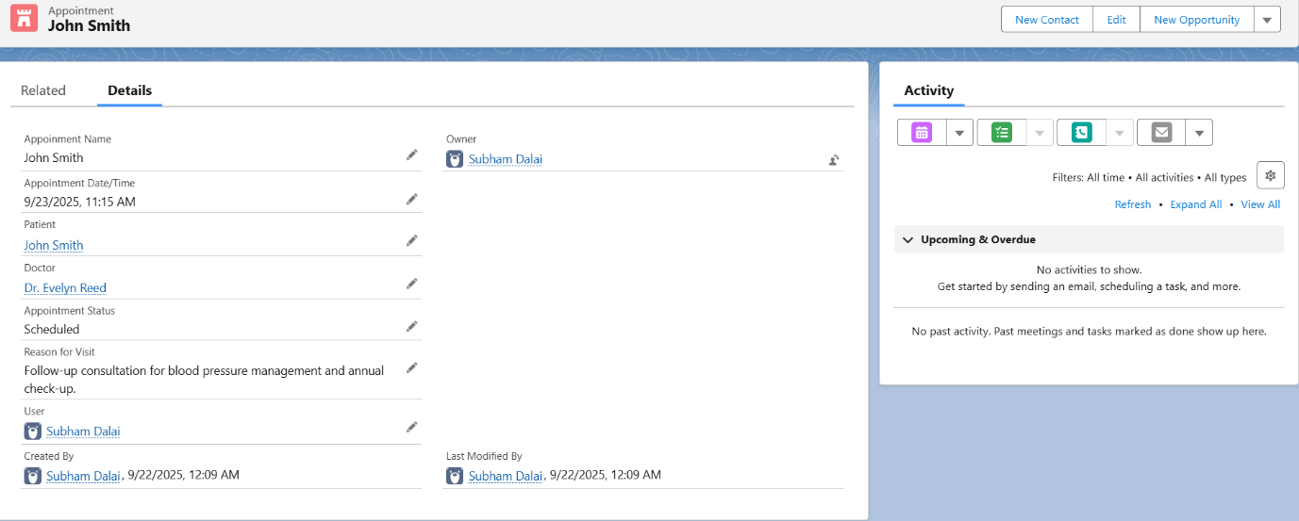

**Tabs Created -:**

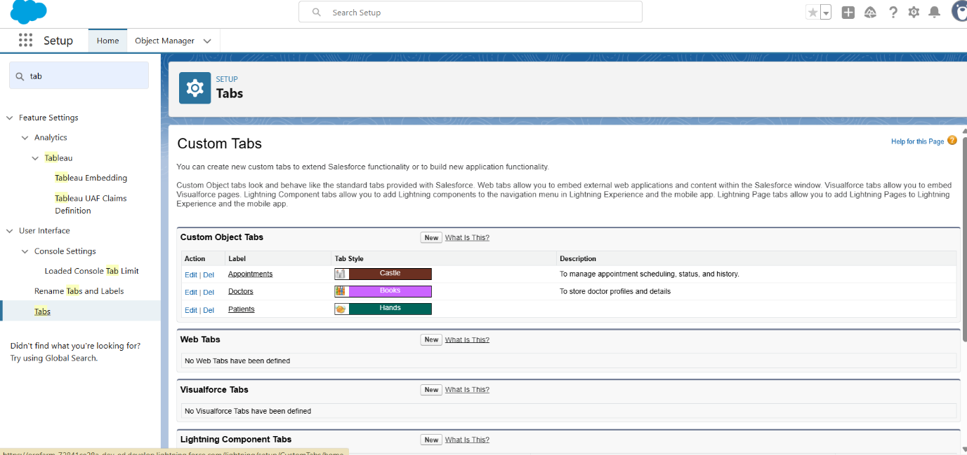

**Name -: Subham Dalai**

**College -: Gyan Ganga Institute of Technology and Sciences**